D-Code

**Expansion Pack #1.0.1**

***System Requirement:*** Loose-leaf sheet of paper, Ink pen

***How to Play:*** Write your name and Expansion Pack 1.0.1. Use the provided images to answer the questions.

1. Element Tab
   1. 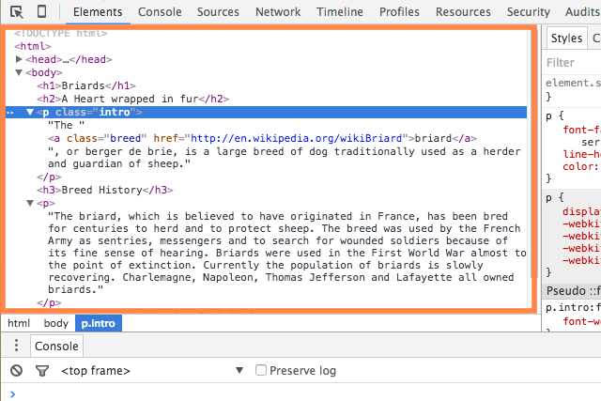What does the “Elements” tab allow you to do?
2. Calculator
   1. 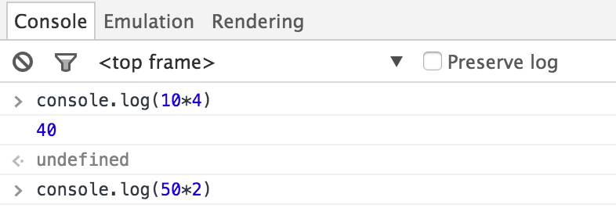What will happen when enter is pressed?
3. Elements
   1. 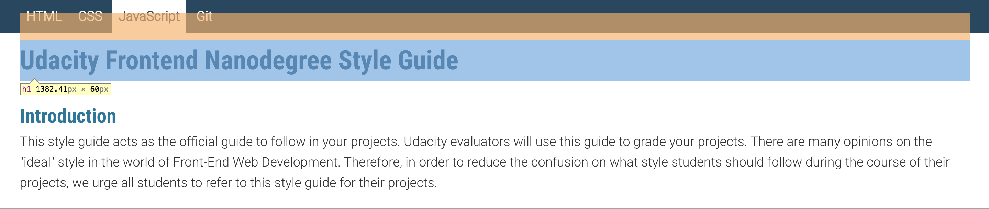An element is being hovered over, which provides the highlighting you see in the image. What do you think the element is called? How big do you think it is?
4. Keep Thinking!
   1. Write an article about what you’ve learned.

D-Code

**Expansion Pack #1.0.2**

***System Requirements:*** Laptop or Desktop computer, Text Editor

***Installation Guide For Developer Tools:***

*Safari:*

1. Select “Safari” menu and Select “Preferences” (shortcut: command comma)
2. Open the “Advance” tab (last tab on the right)
3. Check the box at the bottom of the screen “Show develop menu in the menu bar”
4. Select “Develop” menu and select “Show Web Inspector” (shortcut: option command i)

If you get lost here is the official [link](https://developer.apple.com/library/iad/documentation/AppleApplications/Conceptual/Safari_Developer_Guide/GettingStarted/GettingStarted.html).

*Internet Explorer:*

1. Press the F12 key on your keyboard

If you get lost here is the official [link](https://msdn.microsoft.com/en-us/library/dd565628(v=vs.85).aspx).

***Setup Guide:***

1. Create new file folder named **DCode** on your desktop.
2. Open a new text editor file.
3. Save as **Expansion Pack 1.0.2**.

***How To Play:***

1. Hack Instagram
   1. Go to the Instagram site
   2. Open the Developer Tools, and click on the tab that says “Console”
   3. Type in document.body.innerHTML=“(Here, type in whatever you want!)”, then press enter
   4. What happens? Record your findings in the text document.
2. Calculator
   1. From any site, open the Developer Tools, and click on the tab that says “console”
   2. Type in console.log(2*3);
   3. What happens? Record your findings in the text document.
3. Elements
   1. go to the site <https://udacity.github.io/frontend-nanodegree-styleguide/javascript.html> , and open the Developer tools
   2. click on the “Elements” tab
   3. Move your mouse over the bit of code that starts with <h1>. What happens? (Make sure you are at the top of the webpage?)
   4. Hover over the first <section>. Click on the triangle to the left of it. Hover over the element with the h2 tag.
   5. What do you see? Record your findings in the text document.
4. Keep exploring!
   1. Go to other websites and use developer tools to investigate.
   2. Record your findings in the text document.

Safari link: <https://developer.apple.com/library/iad/documentation/AppleApplications/Conceptual/Safari_Developer_Guide/GettingStarted/GettingStarted.html>

Internet Explorer link: <https://msdn.microsoft.com/en-us/library/dd565628(v=vs.85).aspx>